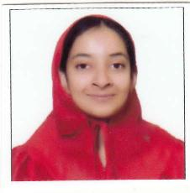

Batul Bohari
E-mail: bohari.batul6@gmail.com
Phone: (+91)8600912300

Education


. 2014 - 2017 B.COM.
. St. Mira’s College of Arts & Commerce
. Affiliated to Savitribai Phule Pune University
. Percentage: 60.58%



. 2012 - 2014 11th - 12th
. Hirachand Nemchand College of Commerce, Solapur
. Maharashtra State Board


2000 - 2012 KG - 10th
Little Flower Convent High School, Solapur
Maharashtra State Board

Skills And Experience
- Computer: Basic knowledge in MS Word, Excel, Powerpoint, Tally
- Languages: English, Hindi, Marathi, Gujarati, Basic French and Korean.
- Adaptability to new environment and multitasking techniques.
- Interned with CA Rajesh Patwardhan in Solapur: May 2017

Online Presence

- Instagram Profile: https://www.instagram.com/batuliful/
- Email Id - bohari.batul6@gmail.com

Hobbies

- Reading
- Plays Tennis
- Interested in photography and travel
- Holds a certificate Hindi and English Olympiad at Secondary and High School level.

PERSONAL INFORMATION

- Date of Birth : 14 May 1996
- Marital Status : Single
- Language : Hindi, English, Gujarati
- Father’s Name : Zoeb Bohari
- Mother’s Name : Farida
- Current City : Solapur
- Address : 11, Vishal Nagar, Jule Solapur, Solapur. 413004.

I hereby declare that all the above information given by me is true of my best knowledge.
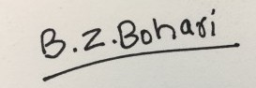
Batul Bohari

